|  |  |
| --- | --- |
| VERNON HISTORICAL SOCIETY  **P.Q. Box 2055**  **Vernon, Connecticut 06066**  **(860) 8754326** |  |

**Request for Historic House Sign**

Date:   
From:

Information on Historic House:

Content of Sign:

Historic Name:

Approx. Date of Construction:

Cost: $50

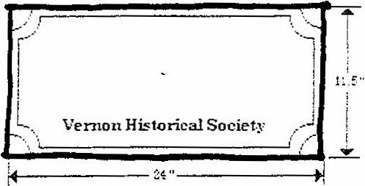

Please make check payable to: The Vernon Historical Society, and mail check with copy of this completed form to:

Director

Vernon Historical Society

P.Q. Box 2055

Vernon, CT 06066

Please include telephone number at which you can be reached when sign is ready

Tel.

To be completed by Vernon Historical Society House Sign Committee:

Payment received:

Sign ordered:

Sign delivered: Museum Director