“The Tankerhoosen: Vernon’s Quiet Valley,”
Lecture: June 2, 2019- 2pm
Bus Trip: Sunday June 9, 2019- 1pm

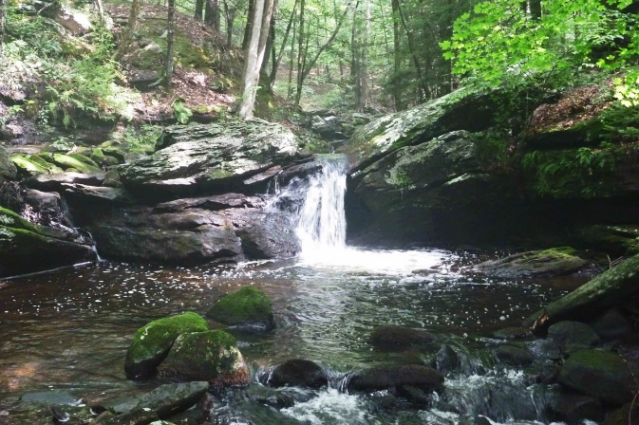

Connecticut’s Route 84 neatly divides Vernon’s 18.1 square miles into two “sister” areas. Both areas of town have similar geographic features that would normally foster the growth of a similar economy in both sections, but on the northern side of the highway, Rockville, grew as an industrial economy with vibrant and busy mills that lined the Hockanum River coursing through the center of town. While, on the southern side, the Tankerhoosen River flowed through an area of rich farmland and wooded hills that fostered an abundant and productive agricultural economy.

On Sunday, June 2, 2019, at 2:00 pm the Vernon Historical Society presents “The Tankerhoosen: Vernon’s Quiet Valley,” a program that will be delivered by Historical Society member, Bob Hurd, who has engaged in extensive research work to learn about this area of our town. We encourage everyone to come and learn more about Vernon’s “quiet and beautiful corner.”

As an added feature, we have arranged for a guided bus tour through Vernon’s Quiet Valley on Sunday, June 9th beginning at 1:00 pm and leaving from the Vernon Historical Society parking lot. Tickets may be purchased for $10 during the June 2nd meeting or by calling the Vernon Historical Society at 860-875-4360 after June 2nd.

The program will begin at 2pm on June 2nd at the Vernon Historical Society’s building at 734 Hartford Turnpike, Vernon. The program is free and open to the public. Donations are always welcome. Light refreshments will be served.

For further information, please call the Society at 860-875-4326 or send an email to vernonhs@sbcglobal.net or visit our webpage at www.vernonhistoricalsoc.org

